**Real Estate management**

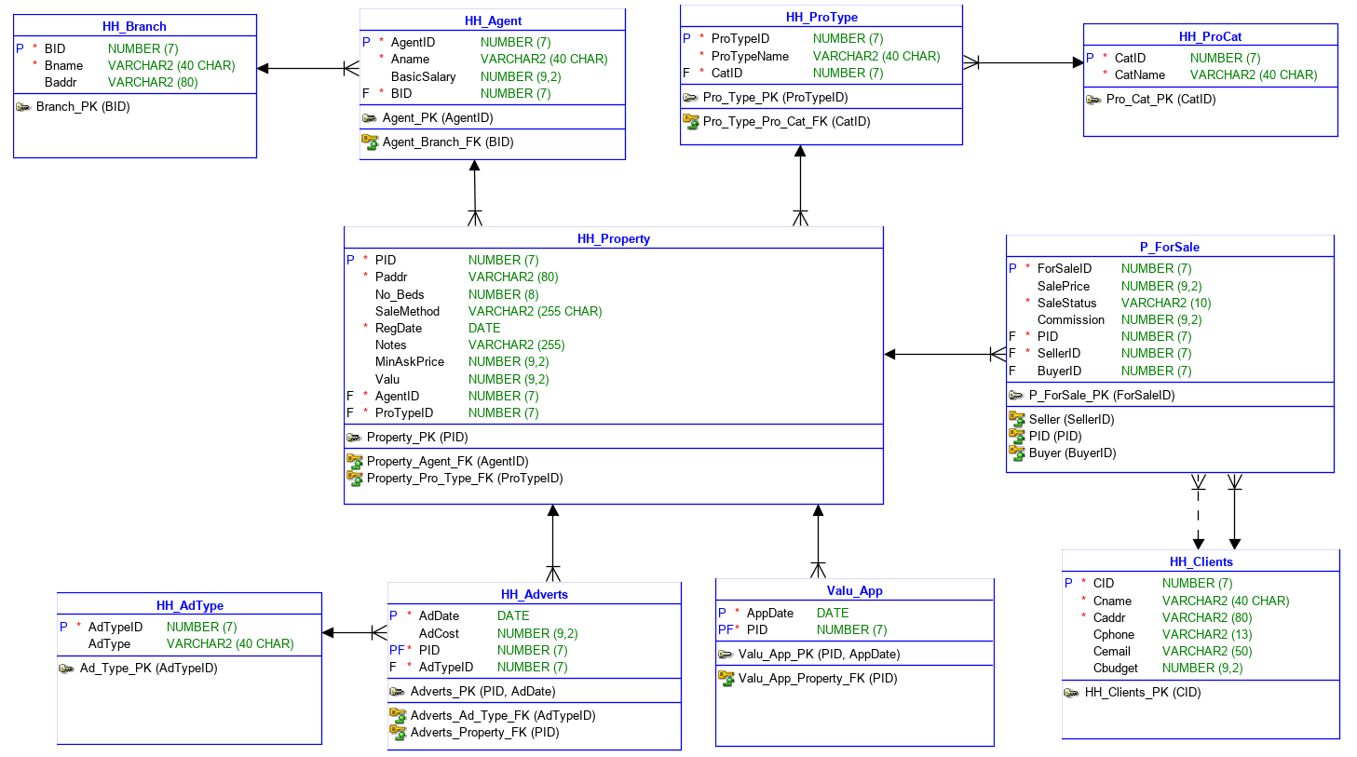

Harry’s Homes is a real estate company operating out of Main Street. It started in the late 1960’s as a small, single person unit. Now, Harry owns a chain of real estate offices in Dublin that handle both of residential and commercial properties.

When a client comes to them with a property, HH send out a valuer, to estimate what the value of the property might be. To sell a residential property, Harry’s Homes needs to know the location of the house, the budget of the client, the minimum number of bedrooms, the method of sale preferred, whether it is a house or apartment. To this, they add their own information – i.e. which office is handling the sale, which agent is responsible for it and the minimum price the client will accept. They also note the date on which the property came on their books, what forms of advertising they did for it and any mitigating circumstances that may affect the sale – e.g. near a dump, previously owned by someone famous, etc.

For each agent, as well as their basic salary, commission is paid on properties successfully sold. Every year, Harry holds a reception at which he rewards the most successful agents. He gives bonuses to the most successful agent in each outlet and then gives prize bonuses to agents by area.

As well as residential properties, Harry negotiates sales of offices, hotels, pubs, retail outlets and properties that are not specific, but are categorised as investment opportunities. Investment opportunities are those that are offered to customers who do not need to use the property, but will buy it for conversion or with some other purpose in mind. These properties do not need to be in good condition, but may be, for example, adjacent to a thriving business that looks as if it may expand, or be in a fashionable location. Some commercial properties may pass through Harry’s Homes several times over the years.

At the moment, Harry’s Homes are confined to Dublin, but Harry wants to expand the business and open new offices in other parts of the country.

When a client comes to offer a property for sale, the property is registered. The client gives all of the information on the property to the desk clerk. They also give information on themselves – how to contact them, etc. An agent is assigned to the property at this time and the client is given an appointment for valuation. The property is marked as being registered, but not valued.

When the agent has checked the house, the findings are entered against the property. The property is now marked as valued. It is also categorised as being residential, commercial or some other category.

Every morning, the agent looks over the properties in his / her portfolio and decides whether they should be advertised. If so, the advertising options are: ‘For Sale’ sign on the property, notice in the paper, picture in the agent’s office window. The agent updates the record of the house to record what advertising has been done on it, with the dates. The publicity an agent gives a property is recorded against the property transaction, and deducted from the agent’s cut of the profit. Each separate advertising transaction is recorded.

When a property is sold, the agent marks it as sold and notes the details of the buyer and the new address of the seller.

Every year, Harry goes through the agent’s portfolios to see who deserves prizes.

|  |  |  |  |
| --- | --- | --- | --- |
| External | Internal Entity | Attribute | Value |
| Harry’s Homes | clients | value | Residential or commecial |
|  | Properties | address | House or apartment |
|  | Branch | budget | sold |
|  | agents | No of Bedrooms | Office |
|  | advertisements | Method of sale | Hotel |
|  | Advert type | Office ID | Pub |
|  | Property Type | Office address | Retail |
|  |  | Minimum price | Investment opportunity |
|  |  | Registration date | Not valued or valued |
|  |  | Property Notes | Property For sale Sign |
|  |  | Basic salary | Newspaper notice |
|  |  | commission | Office window display |
|  |  | Client Name | Seller or buyer |
|  |  | Client Address |  |
|  |  | Client Phone Number |  |
|  |  | Client email |  |
|  |  | Client type |  |
|  |  | Advertisement date |  |
|  |  | Advertisement cost |  |

|  |  |  |  |  |  |
| --- | --- | --- | --- | --- | --- |
| Client | Property | Branch | Agent | Pro_Type | Pro_Cat |
| CID | PID | BranchID | AgentID | ProTypeID | CatID |
| Cname | Paddr | Bname | Aname | ProTypeName | CatName |
| Caddr | noOfBeds | Baddr | BasicSalary | CatID* |  |
| Cphone | SaleMethod |  | BranchID* |  |  |
| Cemail | Reg_Date |  |  |  |  |
| CBudget | Notes |  |  |  |  |
|  | MinAskPrice |  |  |  |  |
|  | ProTypeID* |  |  |  |  |
|  | AgentID* |  |  |  |  |
|  | Value |  |  |  |  |

|  |  |  |  |
| --- | --- | --- | --- |
| Ad_Type | Adverts | Valuation Appointmet | P_ForSale |
| AdTypeID | PID* | PID* | ForSaleID |
| AdType | AdTypeID* | AppDate | PID* |
|  | AdDate |  | SalePrice |
|  | AdCost |  | SaleStatus |
|  |  |  | SellerID* |
|  |  |  | BuyerID* |
|  |  |  | Commission |
|  |  |  |  |
|  |  |  |  |
|  |  |  |  |